**Table of Contents**

Duty Roster Features……………………………………………………………………………………………………………..…Page 1

Filling out the Non-Availability Roster…………………………………………………………….…………………………Page 3

Filling out the Duty Roster…………………………………………………………….……………………………………….…Page 3

**Duty Roster Features**

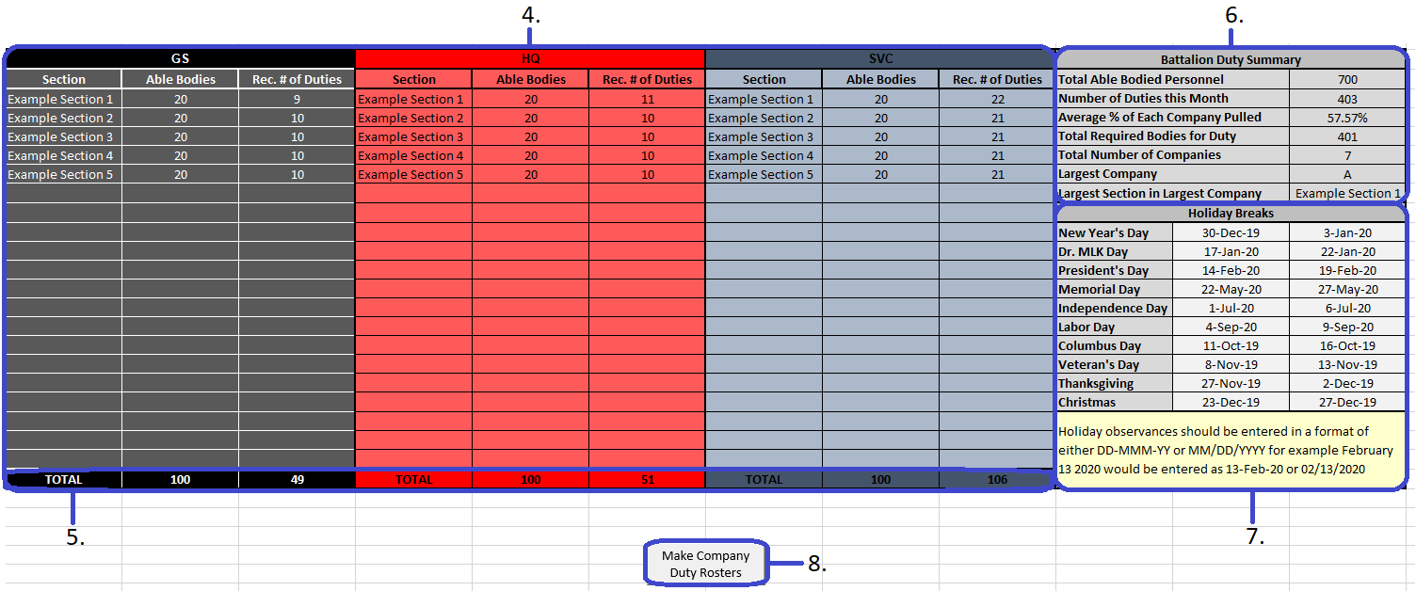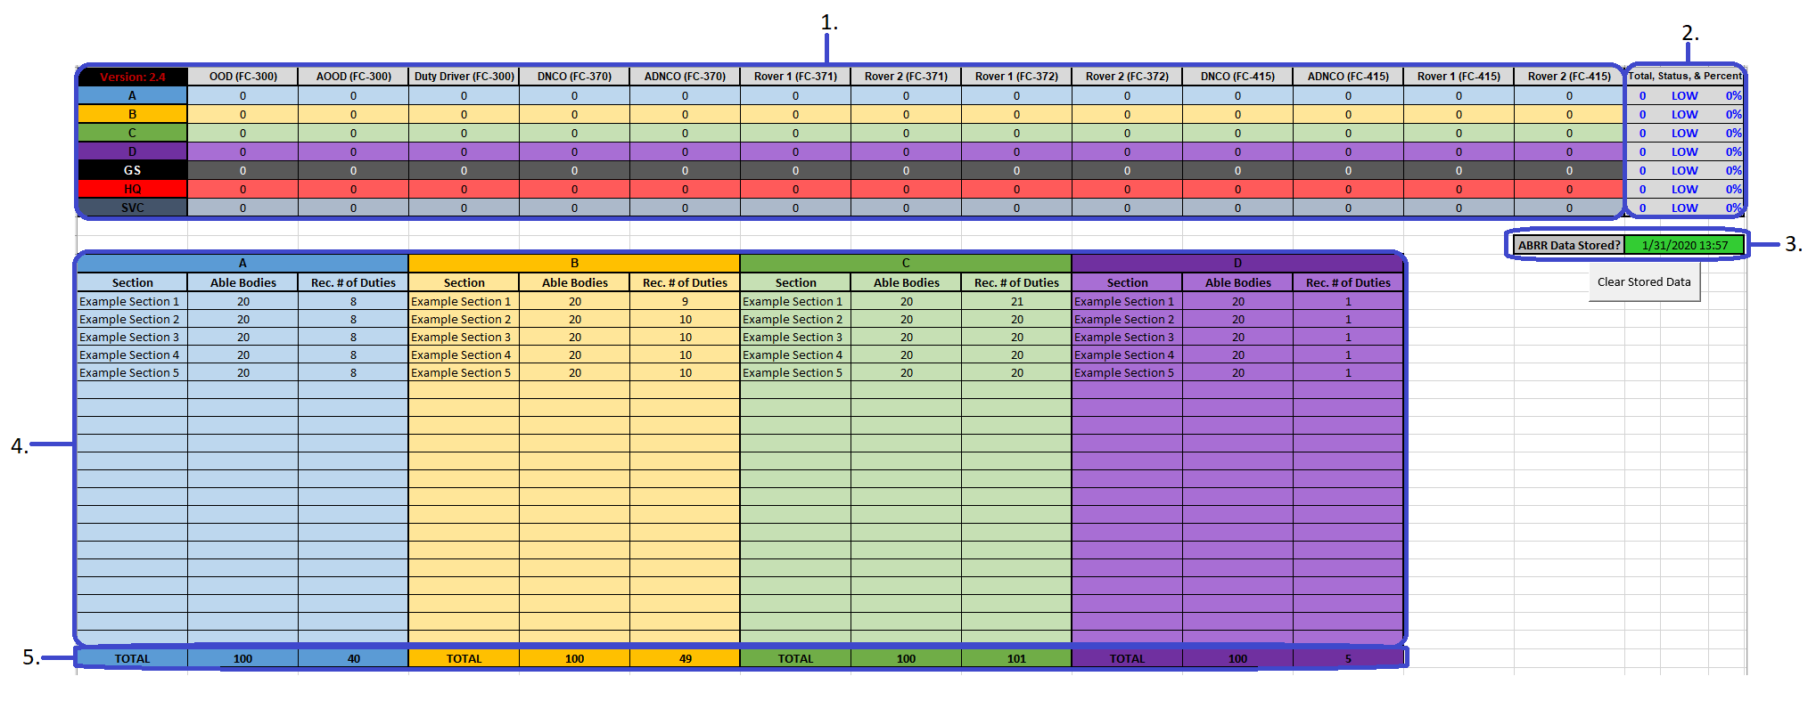Below you can see the layout of the Duty Roster, each section, and what their purpose is.

1. This is the Duty Position Breakdown Chart. This displays the how many duties of each position each company has been allocated.
2. This is the Duty Allocation Summary section. This will display the total number of duties that the company has been tasked with, whether that company’s total number of duties is accurate based on the stored data from the A.B.R.R., and what percentage of the Duty Roster that company make up.
3. This is the A.B.R.R. Data Storage Indicator. This will turn green if it has stored data from the A.B.R.R. and will display the date and time that the information was stored. This allows the user to see how relevant/recent that stored data is.
4. This is the Company Breakdown section. This is for each company to edit and adjust based on how many sections they are made up of. Both the “*Section*” and “*Able Bodies*” are unlocked and can be edited. This will allow each company to input each section of theirs into the “*Sections*” area, then in the “*Abel Bodies*” section they can enter how many personnel each section has who are physically capable and available to stand duty. Using that information, in addition to the stored data from the A.B.R.R. they can see how many duties to allocate to each of their sections.

If a company is having difficulty determining each section’s number of Available Bodies, they can go to the “*AB Roster*” sheet and use the “*Company*”, “*Platoon*”, and “*Full Unit Code*” to apply filters and find how many Marines from each section have been determined as capable of standing duty for that month based on the algorithms and calculations of the A.B.R.R.

As each section has a number of Able Bodied Marines entered into the “*Able Bodies*” section, the number of recommended duties for each section in that company will recalculate and be displayed in the “*Rec. # of Duties*” area.

The number of recommended duties per section is calculated by dividing the number of duty positions the company is tasked with by the number of sections with Able Bodies to find the duty allocation average. Then dividing the total number of that company's Able Bodies by the number sections with Able Bodies in that company to find the company's average able bodies per section. Finally the duty allocation average is divided by the company's average able bodies per section to determine what percentage to pull from each section.

In cases where the company’s total recommended duties does not match what the stored A.B.R.R data suggests, the section with the largest Able Bodies will be altered by either increasing or decreasing their number of recommended duties. In most cases this addition/subtraction is only by 1, but in more extreme cases it can be by 2.

1. This is the Company Breakdown Total section. This shows the total number of Able Bodied Marines as entered into the “*Able Bodies*” section of the Company Breakdown section. It also displays the total number of duties that the respective company is tasked with.
2. This is the Battalion Duty Summary. This area provides a quick reference of summaries for all of the data in the Duty Roster. Most parts are self-explanatory except for possibly the “*Average % of Each Company Pulled*”. The “*Average % of Each Company Pulled*” is rough generalization displaying the average percentage that each company is tasked with duty. This percentage is calculated by taking the sum of each company’s percentage that is used to determine that company’s number of recommended duties per section, then dividing it by the total number of Companies.
3. This is the Holiday Observance Tracker. This is where you can edit the Holiday Observances for the year as they are released by Headquarters Marine Corps. These dates are referenced by each sheet that has a roster to ensure that holidays are highlighted yellow in addition to the weekends. The dates must be entered in with the noted formats otherwise the code will not be able to recognize them as dates.
4. This is the Duty Roster Split/Merge Button. This is where the “*Make Company Duty Rosters*” and “*Make Battalion Duty Roster*” buttons are located. After making the Company Duty Rosters, the button will be replaced with one that will allow you to merge the rosters into one Battalion Duty Roster.

**Filling out the Non-Availability Roster**

The Non-Availability Roster should be fairly straight forward. Just use the drop down to select the rank, and company for each individual. Each individual that is placed on the Non-Availability Roster must have their EDIPI as well as a Start and End date for their non-availability. While not essential, the other fields should be filled out too.

After you have filled out every area for each Marine on the Non-Availability Roster and have ensured it is accurate, save it then email it back to the S-1. **It is imperative that the Non-Availability roster maintains its original naming standard and structure that it was received with.**

**Filling out the Duty Roster**

When you receive the Duty Roster, it should already have all duty positions allocated to the companies. So all you will need to do is fill in the Company Breakdown area to determine how many duties to give each section, based on how many Marines they have that can stand Duty.

Once you have entered each section name and their number of Able Bodies, you can begin to assign duties to each section in your company. When filling each position with a Marine, ensure that you use the dropdown for Rank selection, include first and last names, and have a valid phone number. This will help prevent issues later on when each company’s Duty Roster is merged into one Battalion Duty Roster.

After you have filled out every position that has been allocated to the company with the relevant information and ensure it is accurate, save then email the Duty Roster back to the S-1. **It is imperative that the Duty Roster maintains its original naming standard and structure that it was received with.**